RFP #27-02 Dual-Lift 911 Dispatch Consoles
Notes from Pre-Bid Conference on October 22, 2026
Posted: October 27, 2026

The meeting started at 2:00 pm on Thursday, October 22, 2026 with Brad Johnson, County Manager, Sonia Sands, E-911 director and JoAnna Phillips, Procurement Coordinator present. There were approximately 8 suppliers on the zoom.
- Do you want the same layout?
Do you want your current look/design? We are looking for suggested console layouts. The 5-monitor layout is the only definitive part at this time.
- Second Floor Design and Requirements
Brad explained that the second floor will have a soak-in design with void space under the floor, where wiring and electrical components will be located. He confirmed they plan to follow the RFP requirements for fairness, including specifying five consoles for a new facility with proper ergonomics and a large screen. The discussion ended with Sonya being asked about the monitor layout from their current center, but her response was not captured in the transcript.
- Module Layout and Monitor Configuration
The module layout and monitor configuration would remain the same as depicted on page four of the RFP. Someone requested the model number for the 85-inch monitor to obtain specifications including weight, and Brad agreed to provide this information after the meeting. Another participant asked about receiving electronic or CAD drawings of the room, though this request was not explicitly addressed.
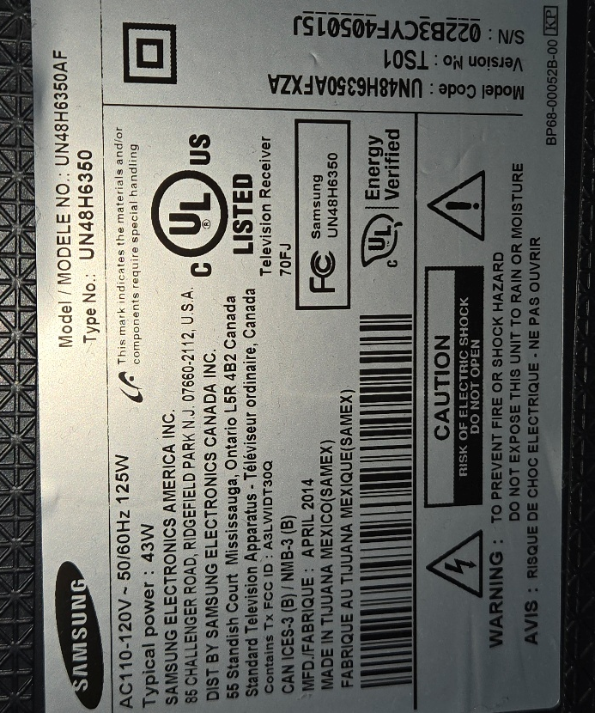
Here are the current large monitor serial numbers:

Monitor #1

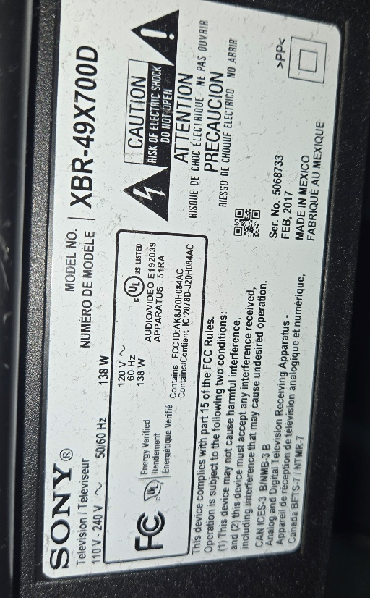
Monitor #2

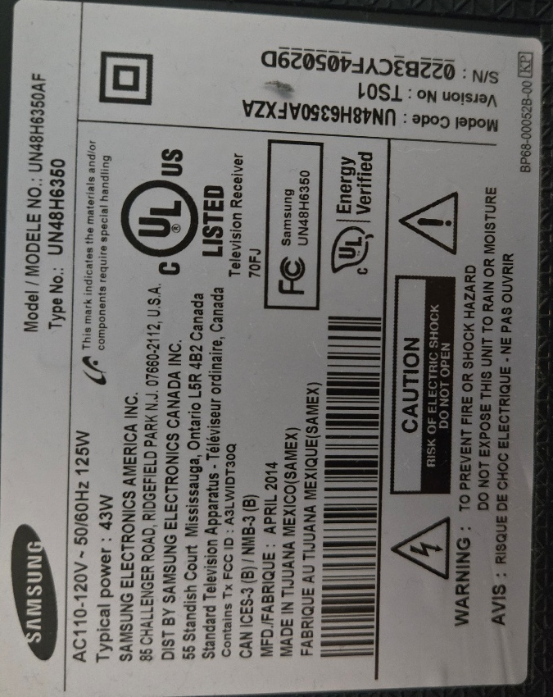
Monitor #3

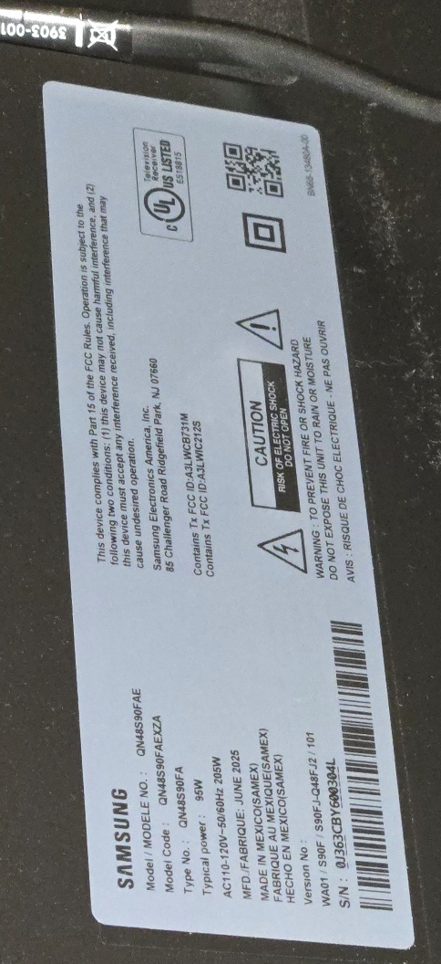

Monitor #4

- Architectural CAD Drawings Discussion
The team discussed using architectural CAD drawings for design work, with Brad confirming they would provide the dimensions needed for the project. Ellie inquired about the supervisor's platform dimensions, and Brad explained it would be customized based on the selected console, with suggested dimensions of 32 by 2.25 and 40 by 3.25 for future design work. Brad clarified that the platform would be designed to accommodate the chosen furniture rather than being pre-built.
- Raised Floor Installation Planning
Brad clarified that the raised floor will be built on site with wiring and conduit installed underneath and confirmed they have a contractor handling the installation. Ellie raised questions about a potential noise-canceling panel system behind consoles and the number of computers to be housed in the cabinets, with Brad indicating two computers would be housed in the cabinets. Brad encouraged anyone with additional considerations to submit supplements or addendums for review.
- Console Specifications Discussion Meeting
Brad and Ellie discussed console dimensions and specifications, with Brad clarifying that they would need to correct the 85-inch monitor specification to either 55 or 75 inches. They agreed that an addendum would be sent out after their meeting, which would include climate control and lighting options for the consoles as requested. The team also discussed handling additional technical questions through the addendum process, with a deadline for question submissions to be included in the packet.
- Console Dimensions and Design Discussion
The console screen is approximately 48 inches rather than 85 inches as initially discussed, and agreed to provide confirmed dimensions and a photo of the current setup. He indicated a preference for a neutral color scheme similar to the room's off-white or light gray base, and confirmed that while they are open to alternative layouts, they prefer to start with the current layout shown in the RFP. Brad requested that any additional questions be submitted to Joanna for compilation into an addendum, noting this is their first time purchasing a new console.

Current consoles contain 2 towers on each side (in cabinets) and another mounted under the main desk. Each tower has a separate keyboard. All station will upgrade to have 2 (two) 24” monitors on each side plus the 48” monitor in the middle. Each station will go from having 3 monitors to 5.
Below are the current stations. However, this RFP request the submitted bids to include layout suggestions and options. All wiring needs to be hidden but accessible. Lighting suggestions would be appreciated as well as charging (USB and USB-C) and electric accessibility.

CURRENT TRAINING STATION.
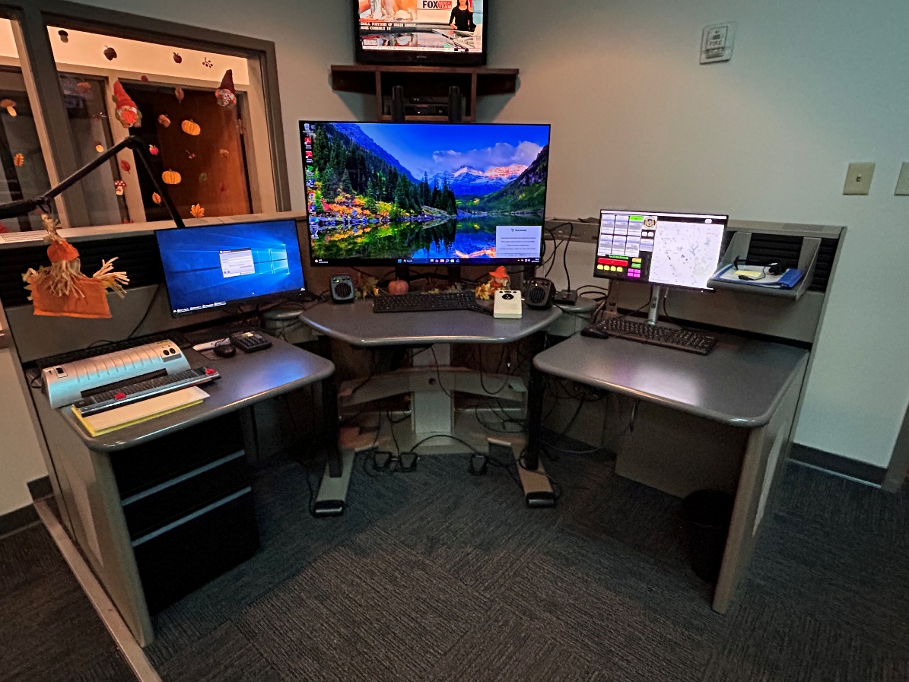

CURRENT: 2 PERSON STATION
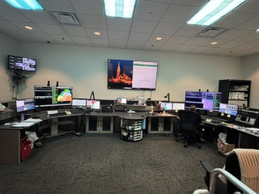

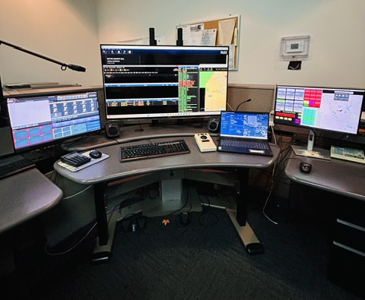
CURRENT SUPERVISOR STATION

