RFP #27-02 Dual-Lift 911 Dispatch Consoles
Addendum #1:
Posted: November 6, 2026

- Is the county looking to purchase the displays as part of this bid, or are they only wanting to purchase the consoles through this bid with the AV portions to follow later? This RFP is for the design and consoles only.
- During the pre-bid meeting, it was stated that the 85-inch monitor listed in the technology chart would be changed to a 55-inch monitor. Could you please confirm whether that is correct? If so, is the make and model of the 55-inch monitor available?

Mounting requirements for large-format monitors can vary by manufacturer and model, so having this information would help us ensure that we include the proper mount in our proposal and provide the most accurate solution for the Butts County team.

Please let me know if you have any questions or need any additional information from us. We look forward to your response and thank you for the opportunity to provide a proposal for this project. The Pre-Bid meeting notes published 10/27 should be clarified as the 85” monitor is a 48”.

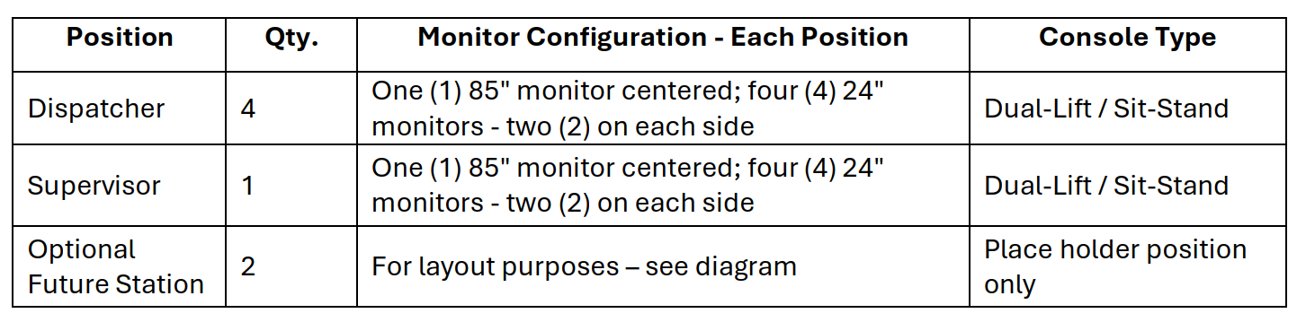
- Do you know if there are any plans for chairs at all? Currently, we are only looking for consoles. Furniture such as chairs will be a future consideration.
- PGSS is reviewing the five dispatch-console RFP 27-02. Could you clarify whether a qualified console manufacturer/installer can bid as prime with a referral or sourcing partner, and whether the 5% bid bond and 100% performance/payment bonds apply to the complete turnkey console procurement? We understand the written solicitation and addenda control and will not submit a bid without meeting all requirements. Yes, the bid and performance bonds are required from the winning bidder
- . Installation site: What is the street address of the new 911
Emergency Communications facility for delivery and installation
(ship-to)? 1578 Highway 16, Ste 911, Jackson, GA 30233
2. Center monitor: The RFP specifies one 85-inch center monitor per
position; the October 22 pre-bid conference indicated that size will
be corrected by addendum (approximately 48 inches per the current
setup, with 55 or 75 inches discussed). Please confirm the corrected
size, and the monitor make/model and weight if available. Covered in the post pre-bid conference notes from 10.22.26
3. Radio system: What dispatch radio system (make and model) will be
used in the new facility, and is there a back-up radio system (make
and model)? Covered in the post pre-bid conference notes from 10.22.26
4. CAD system: What CAD system (make and model) will the Agency be using? TBD
5. 911 telephone system: What 911 telephone system (make and model)
will the Agency be using, and will there be a back-up phone system
(make and model)? TBD
6. Position equipment: Equipment is not included in the RFP. How many
phone sets, radio sets, and speakers per console position should the
consoles be designed to support? Covered in the post pre-bid conference notes from 10.22.26
7. Electrical: How many UPS circuits will be available for each
console position, and at what amperage? Will a utility circuit be
available for each position, and at what amperage? What receptacles
will the County provide to support the UPS and utility circuits? The county will provide depending on the need
8. Data: How many data cables will be allocated to each console position? TBD
9. Access floor: What is the height of the raised access floor on the
second floor? 8”
10. Ceiling height: What is the ceiling height within the dispatch center? 10'
11. Receiving and access: Are receiving docks available, and is the
receiving area dock level or ground level? If an elevator is required
to move the consoles to the second floor, what are its dimensions (W x
L x H)? What are the doorway widths and heights on the delivery route,
and the hallway widths? Single story new building
12. Installation hours: What hours of the day/night will be dedicated
for delivery and installation? 8-4:30 M-F
13. Drawings: Will the County provide AutoCAD or architectural
drawings of the dispatch room for furniture layout purposes, as
discussed at the pre-bid conference? See below



